LAB ASSIGNMENT – 20.3
NAME:H.V.S.Vyshnavi
H.NO:2403A51182
TASK-1:
Prompt:
“Generate a simple Python username-password login program. Then review the code for input validation vulnerabilities, identify weaknesses, and provide a secure version of the script with proper input validation — for example, using the re module.”
Code:
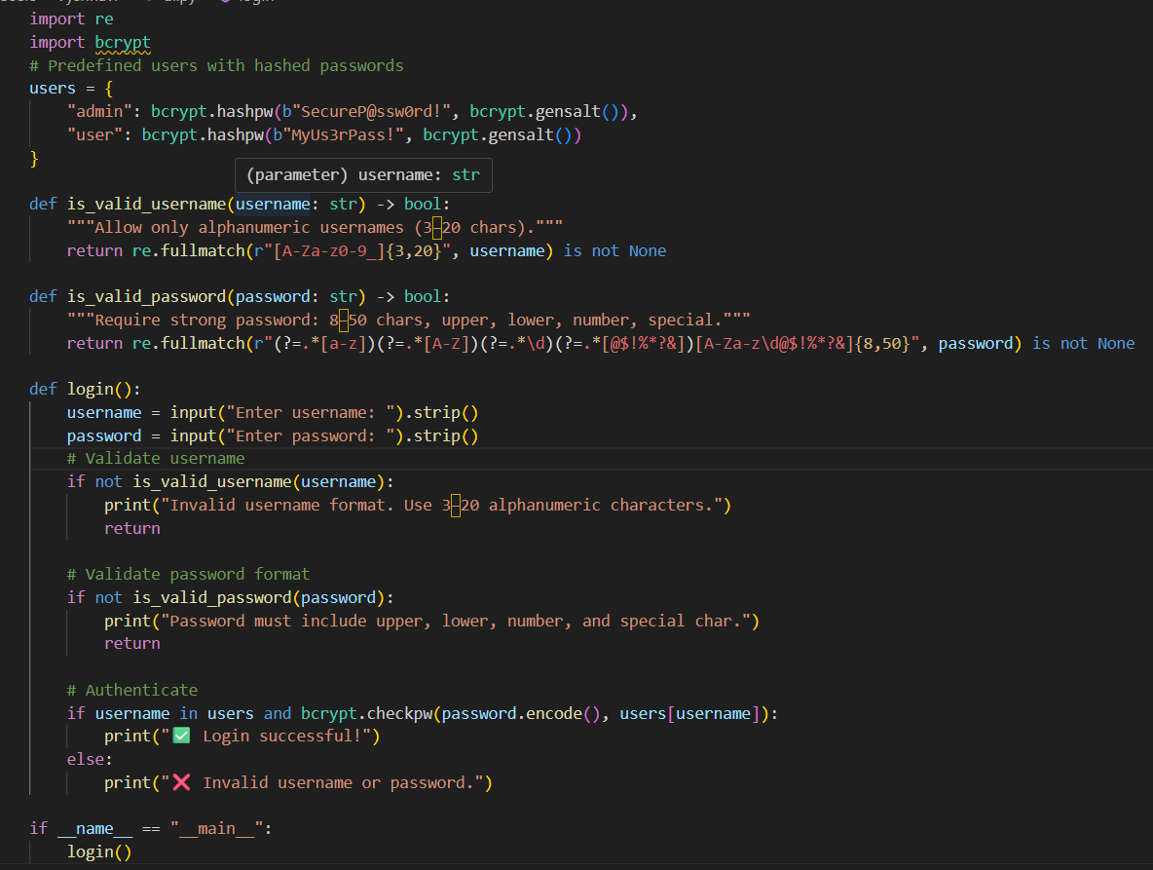
Output:
Observation:
Aspect | Observation / Findings
Generated Script | The original AI-generated Python login program accepted any user input for usernames and passwords without validation or sanitization. Passwords were stored in plaintext in a dictionary.
Vulnerabilities Identified | 1. No input validation (users could enter special characters, blank input, etc.) 2. Plaintext password storage (security risk). 3. No password complexity enforcement. 4. No protection against brute-force or repeated login attempts.
Security Improvements Suggested | - Added regex-based input validation using Python’s re module for both username and password. - Enforced strong password rules (uppercase, lowercase, digit, special character). - Used bcrypt to hash passwords securely instead of storing them in plaintext. - Trimmed whitespace and sanitized inputs before checking.
Secure Script Outcome | The improved version validates all user inputs, securely stores passwords as hashes, and provides clearer error messages for invalid inputs. It greatly reduces the risk of injection, weak credentials, and insecure password handling.
Issue Encountered During Execution | The error ModuleNotFoundError: No module named 'bcrypt' occurred because the bcrypt package was not installed.
Resolution | Installed bcrypt using pip install bcrypt. After installation, the script ran successfully.
Further Improvements (Optional) | - Implement account lockout after repeated failed logins. - Log failed attempts for monitoring. - Use environment variables or configuration files instead of hardcoded credentials.
TASK-2:
Prompt:
Run the script secure_sqlite_fixed.py and enter a username to fetch user details from the local SQLite database.
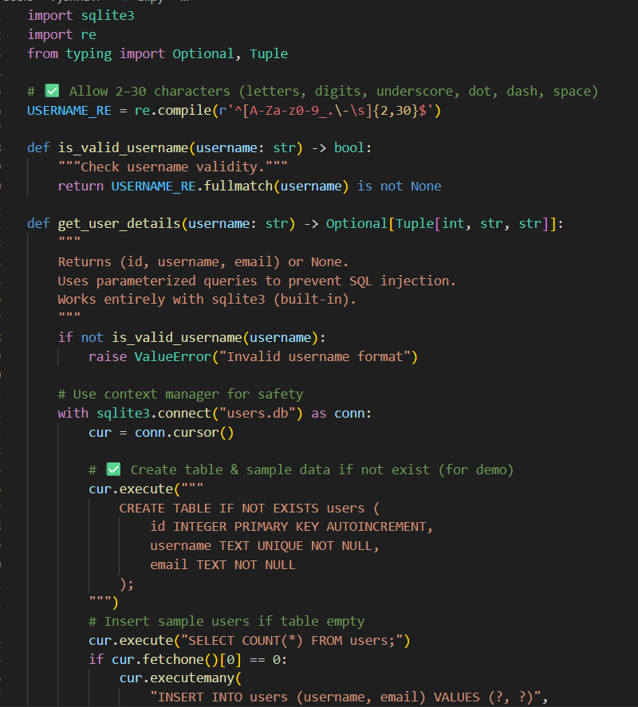
Code:

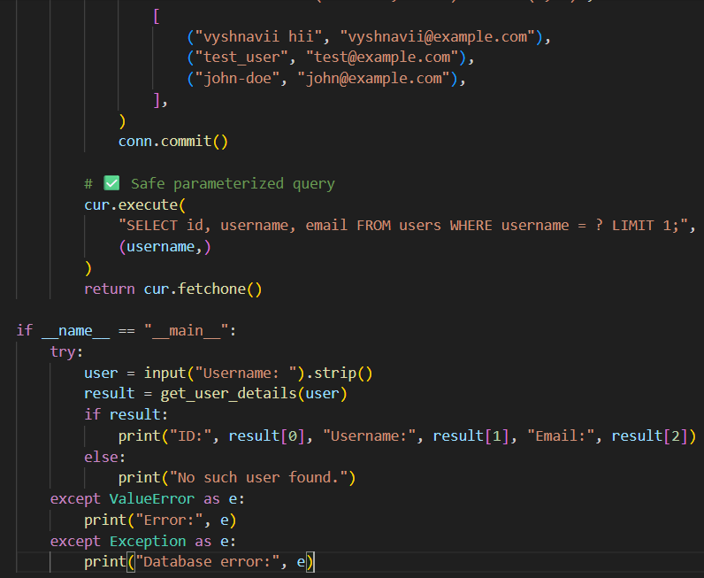
Output:
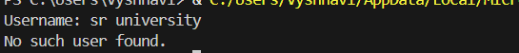
Observation:
- If the username exists:
ID: 1 Username: vyshnavii hii Email: vyshnavii@example.com
- If the username does not exist:
No such user found.
- If the username is invalid:
Error: Invalid username format
TASK-3:
Prompt:
Run the HTML feedback form in a browser and submit feedback with normal text and malicious input (e.g., <script>alert('XSS')</script>) in the username or message fields.
Code:
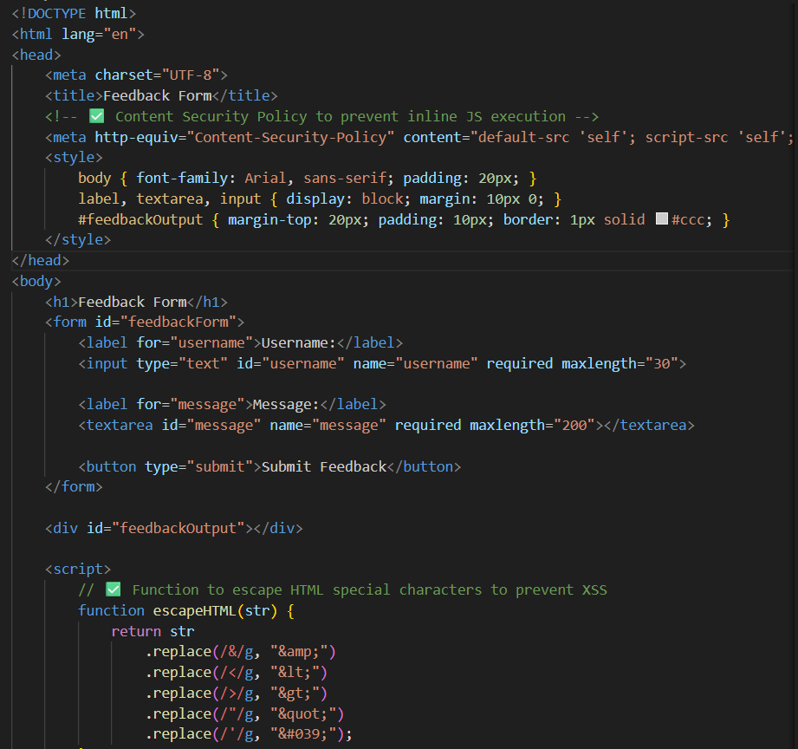
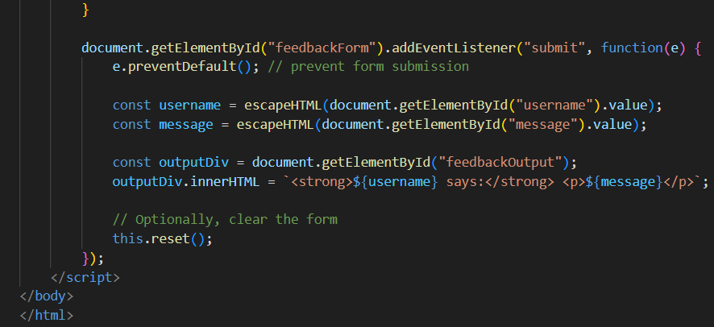
Output:
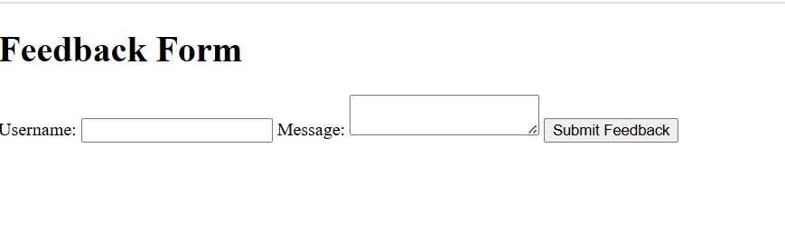
Observation:
- Normal input displays correctly in the feedback area.
- Malicious input is escaped and shown as plain text:
- <script>alert('XSS')</script>
→ No alert is triggered.
- The form is protected against XSS due to HTML escaping and Content Security Policy (CSP).
TASK-4:
Prompt:
Open the HTML login form in a browser and enter test usernames, including malicious input like <script>alert('XSS')</script>. Submit the form to see how the input is rendered.
Code:
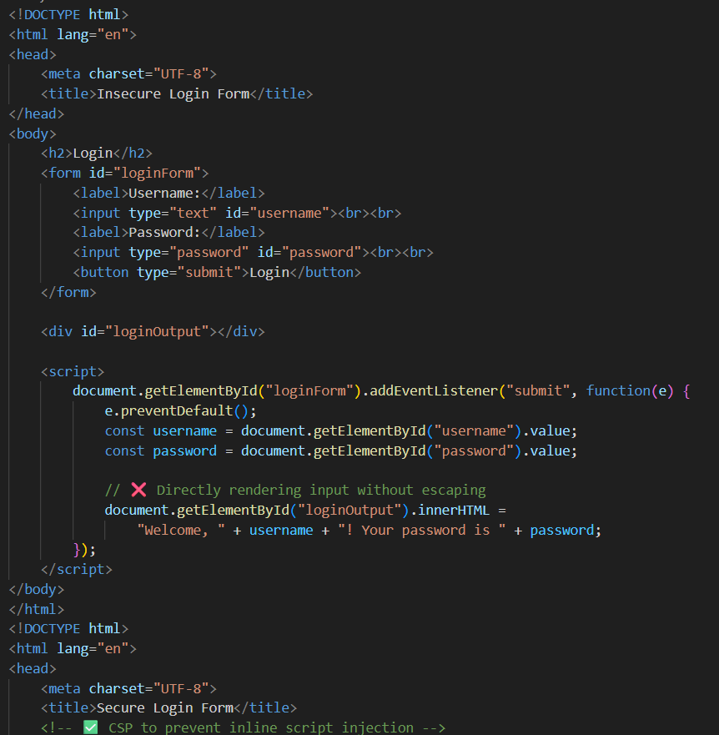
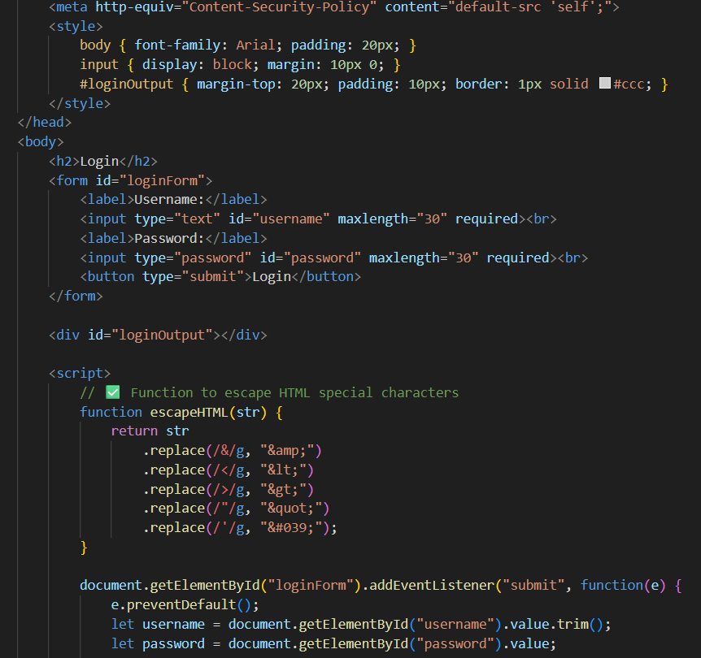
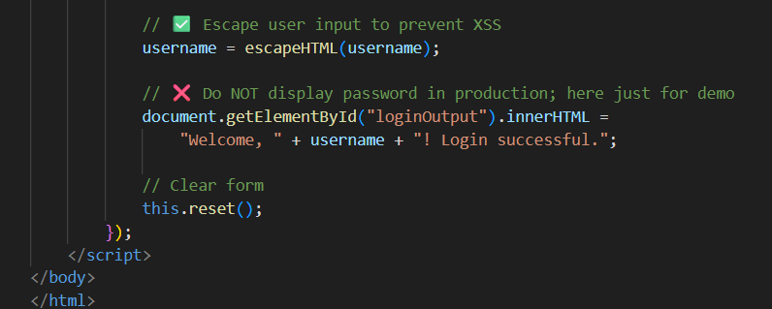

Output:
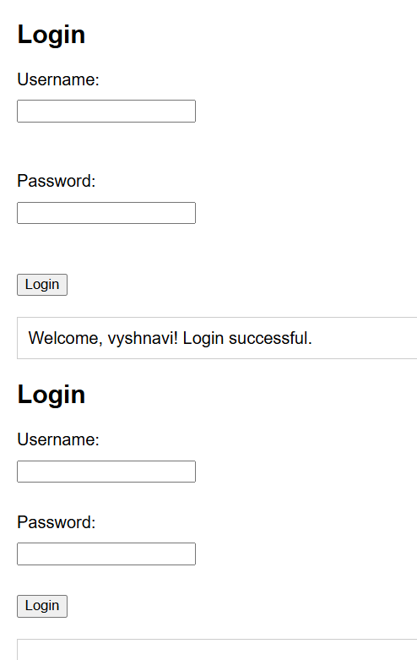
Observation:
This task encourages students to critically evaluate AI-generated code for security weaknesses, actively learn secure coding practices, and understand the difference between insecure and secure implementations. It promotes hands-on experience in identifying vulnerabilities, applying AI-assisted solutions, and documenting the improvements, reinforcing both coding and cybersecurity awareness.

